My project will be creating the game Guitar Hero

This game will involve a few songs. The user will be clicking keys which are in rhythm to the song chosen. The rhythm will be determined by the game; the user must follow the same rhythm. The user will see which key to click and must click it on the right time. The user wins if he/she doesn’t miss a lot of keys.

The libraries I could use

Tkinter or pygames

pymedia

random

Features of the game

Basic features:

There will be a starting menu which has an “instruction” button and a “play” button.

The game will have a choice of two songs.

The user can pause, restart, or exit the game after it started.

There will be a score bar, to show the user how will he/she did.

There will be 4 keys to be pressed.

Special features:

When a user misses a key or clicks the wrong key, an annoying song will come out.

If the user misses too many keys there will be booing from the crowd.

The crowd will cheer if there were no misses for a long time.

The user can choose a character that represents them

I will add more songs if I had time.

The user can change the speed of the game.

The interface:

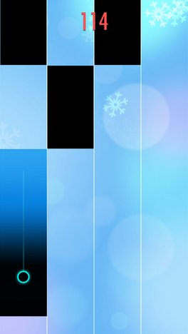

Figure http://cdn.amz.appget.com/convimg/jpg-wh468-1456877872http://appget.com/review_image/9616_screen_2

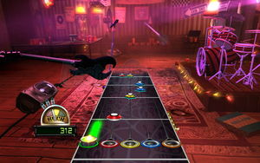Figure http://guitarhero.wikia.com/wiki/Recording_Studio

The above are examples of what a guitar Hero Game looks like. Mine will probably look like the one on the right.

When the game is started a menu will show up. When the user clicks play they will be directed to a window that looks similar to the blue one above.

By Sunday November 13th,

My goal is to be done with the user interface and to fulfill the basic features I mentioned earlier.